TARGETING B-RAF KINASE IN MELANOMA
Posted by Arup R Chakraborty on Wed, Mar 13, 2013

Melanoma is a type of skin cancer. It arises from specialized pigmented cells in our body known as melanocytes that are responsible for the production of melanin (a pigment responsible for skin and hair color). Because most melanoma cells still make melanin, melanoma tumors are usually brown or black. It accounts for 4% of all skin cancers; however, it is responsible for the largest numbers of skin cancer related death in the world. In the US, according to the national cancer institute, estimated new cases and deaths from melanoma in 2013 would be 76,690 and 9,480 respectively.
Several studies using molecular profiling and genomic sequencing have shown that melanoma is a disease of a heterogeneous group of tumors, and its progression is driven by specific oncogenic mutations. In 2002, Davies et al. first reported the presence of B-RAF somatic missense mutations in 66% of malignant melanomas. RAF (Rapidly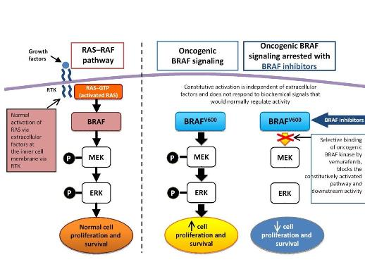 growing Fibrosarcoma) protein is a serine/thereonine kinase. Three members of this kinase family are A-RAF, B-RAF, and C-RAF. These serine/threonine protein kinases, downstream of the membrane-bound small G protein RAS, are components of the mitogen activtated protein kinase (MAPK) signal transduction pathway. With closely overlapping functions, all members of the RAF family are associated with the activation of the MAPK pathway. Activation of the MAPK pathway has been associated with uncontrolled growth and drug resistance in several tumors. Researchers have identified over 50 distinct mutations in the B-RAF gene so far. However, most of these mutations are extremely rare. The most common mutation in melanoma, accounting for 90% of all B-RAF mutations, is the V600E mutation that occurs as a result of substitution of amino acid valine (V) to glutamic acid (E) at codon 600. Approximately 50% of melanomas harbor the V600E B-RAF mutation, while other mutations observed in melanomas are usually associated with the activation of N-RAS and c-KIT.
Several studies reported association of the V600E B-RAF mutation with the progression of melanoma. In a pre-clinical study Smalley et al. (2010) observed tumor formation in immunocompromised mice following introduction of mutant B-RAF in melanocytes. Inversely, in their study, Smalley et al. also observed that inhibition of mutated B-RAF using RNA-interference resulted in tumor cell death. In addition, several other studies reported that inhibition of V600E mutant B-RAF prevents melanoma cell proliferation, induces apoptosis (programmed cell death), and also blocks melanoma xenograft growth in vivo. Even though many studies suggested that V600E B-RAF mutation may not be sufficient alone for melanoma induction, a wealth of evidence demonstrated that mutated B-RAF is necessary for the maintenance and progression of melanoma in human. Therefore, mutated B-RAF represents a therapeutic target in melanoma, which is why several B-RAF kinase inhibitors have already been developed. Sorafenib was the first B-RAF inhibitor studied in melanoma patients. In addition, vemurafenib (Zelboraf) and dabrafenib (GSK2118436) were also studied in melanoma patients with V600E B-RAF mutations. In 2011 vemurafenib received FDA approval for the treatment of melanoma patients harboring the V600E B-RAF mutation. In clinical trials, in which patients were undergoing treatment with vemurafenib, the drug reduced risk of death by 63% and risk of progression by 74%.
At present several clinical trials also evaluate clinical efficacy of vemurafenib in combination with leflunomide (antirheumatic drug), GDC-0973 (MEK inhibitor), and metformin (antidiabetic drug). In addition, several other drugs targeting B-RAF and its downstream pathway are also in development. Therefore, further improvements can be expected in this personalized and targeted therapy in melanoma.

